Dandie Dinmont Terrier  History  The Dandie Dinmont Terrier as a breed has existed for well over 300 years. First known as Pepper and Mustard Terriers, they originated in the Scottish Border Country and were owned by gypsies.  They gained their popularity and unique name from Sir Walter Scott who included a description of them in his book Guy Mannering or The Astrologer (1815). On the web at:  http://ebooks.adelaide.edu.au/s/scott/walter/guy/  In this book a pack of Mustard and Pepper Terriers were owned by a character called Dandie Dinmont and it is from him they gained their quaint and unusual name.  Dandie Dinmont Terriers share common ancestry with Bedlington Terriers, Skye Terriers and Scottish Terriers; they were also used in development of wire-haired Dachshunds and the Australian Terrier.  Today, despite it's endearing personality, soulful eyes, tasselled ears and magnificent topknot, the Dandie is not a well known breed. Those lucky enough to own one call it "The best kept secret". Consequently the Dandie is a rare breed with only a few hundred born around the world each year. | Original Use  Used to hunt Otter, Badger and other small game and vermin.  Temperament  The Dandies have been described as the most placid and docile of the Terriers, he is not prone to snappiness or yapping.  His demeanour is one of intelligence and tolerance. He has a friendly disposition and a great sense of humour and fun.  He enjoys the company of both adults and children and will be both an active playmate and loving lap sitter.  He is not a dog that would suit someone looking for an "outside" dog as he likes to be part of the family.  The Dandie is an intelligent and sensitive dog with a big personality and a big bark for his size. He can be stubborn and can sulk if his feelings are hurt.  The Dandie will generally get on well with other pets as long as they are brought up with them.  They do not generally instigate conflict with other dogs but when offended are fearless opponents. | Care of the Dandie  Dandies are generally healthy and hardy little dogs. They enjoy a walk but do not require extensive or daily exercise. Like all puppies as youngsters they can be naughty and disobedient.  Having big personalities and a healthy sense of self, training using rewards rather than punishment is the most effective method of training. Being a long bodied dog it is important that they not be allowed to get too fat.  As youngsters Dandies are uncoordinated and until mature, stair climbing should be kept to a minimum.  Grooming  Dandies do not moult (drop hair) making them an ideal house-dog.  However their coat does require regular care. The coat should be thoroughly brushed at least once a week to remove knots and dead hair. Professional grooming is needed approximately 3-4 times a year.  As the Dandie has a profuse silky topknot and large soulful eyes it is recommended that the hair above the eyes and on top of the nose be trimmed regularly to keep it from causing any irritations.

Average Life Span  11 - 15 years  Average Weight  9kg – 13 kg  Colours  Pepper … grey body with silver legs, silver head hair and beard.  Mustard … golden orange body, cream legs, cream head hair and beard.  Ideal Owner  The Dandie is an ideal pet for anyone with a sensible and responsible attitude to dog care.  Dandies make excellent family pets and are a great companion for the single person whether young or old.  AMDD 28JY21 | Who to Contact  www.dandiesinoz.com.au  Victoria  Emma Greenway: +61 (0)3 9761 3182  jollygaze@optusnet.com.au  Queensland  Gwen Hovey: +61 (0)7 3409 4705  Tasmania  Teena Sloan: +61 (0)4 3827 1060  killilan@bigpond.com  Puppy Availability  The Dandie Dinmont is a rare breed.  Expect to wait 3-9 months for a puppy.  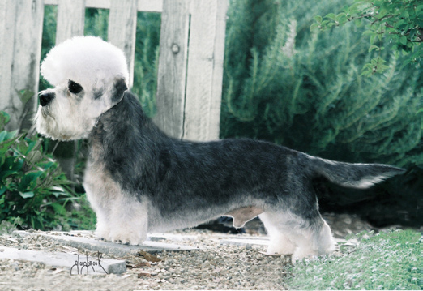   | The  Dandie Dinmont  Terrier

